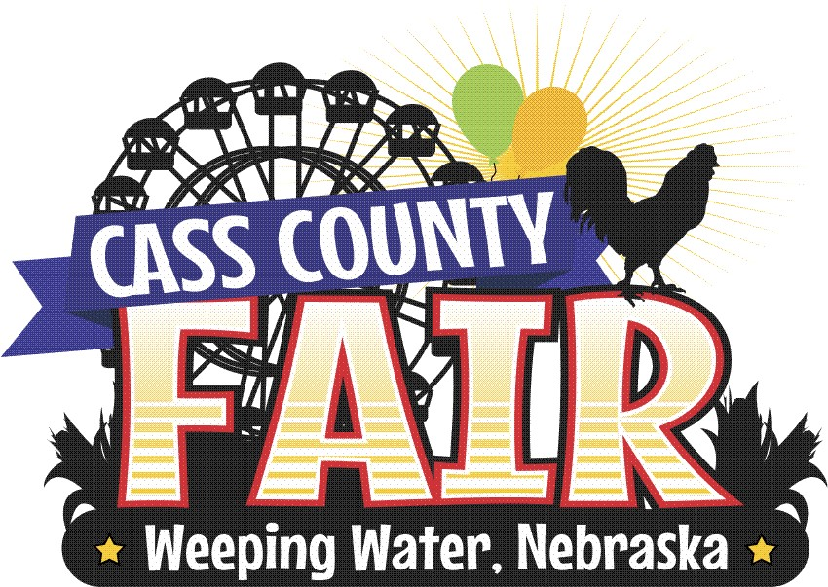
2022 Cass County Fair’s Grandparents/Special Senior Friend of the Year Award

Name___________________________________________________________

Town ___________________________________________________________

Age______

My Grandparent or Special Senior Friend is:

Name __________________________________________________

This essay and picture should be turned in to a basket in the Fair Office by 5:00pm Wednesday, August 10. Winners of 1st, 2nd, and 3rd places will be announced at 6:00pm Thursday, August 11 in the Expo Center.

HAND-DRAWN PICTURE OF MY GRANDPARENT OR SPECIAL SENIOR FRIEND
AND ME (Can be drawn in crayon, marker, pencil, etc.)

………………………………………………………………………………………………………………

Phone number of child’s parent: ____________________ (Will be removed before public display)

WHY I THINK MY GRANDPARENT(S) OR SENIOR FRIEND DESERVES TO BE THE GRANDPARENT/SPECIAL SENIOR FRIEND OF THE YEAR
_________________________________________________________________

_________________________________________________________________

_________________________________________________________________

_________________________________________________________________

_________________________________________________________________

_________________________________________________________________

_________________________________________________________________

_________________________________________________________________

_________________________________________________________________

_________________________________________________________________

_________________________________________________________________

_________________________________________________________________

_________________________________________________________________

